

SUPERIOR UNIVERSITY LAHORE
GOLD CAMPUS

NAME: MUHAMMAD MOIZ RAZA
ROLL NO: SU92-BSAIM-F24-061
PROGRAM: ARTIFICIAL INTELLIGENCE
SEMESTER: 4th SEMESTER
SECTION: BSAI-4A
SUBJECT: PROGRAMMING ARTIFICIAL INTELLIGENCE

Submission Title: PROJECT
- FACE RECOGNIZATION ATTENDENCE SYSTEM
Submitted To: Sir RASHIK ALI

Contents
Introduction 3
Background 3
Purpose of the Project 3
Real-World Problem Solving 3
Technology Used 4
Working of the System 4
Student Registration 4
Data Preparation & Training 4
Face Detection 5
Face Recognition 5
Attendance Marking 5
Data Storage & Reports 5
Simple Flow of System 5
Examples of Use 6
Features 6
Future Scope 6
Conclusion 6
GUI: 7
Dashboard 7
ADD STUDENT AND CAPTURE FACES 7
VIEW STUDENTS 8
MARK ATTENDENCE 8
VIEW RECORD 9

Introduction
In today’s world, technology is making our daily tasks easier and faster. One such task is attendance management. The Face Recognition Attendance System is designed to automatically mark attendance using a person’s face. Instead of using registers or ID cards, the system uses a camera to recognize faces and mark attendance.
This project uses basic machine learning and image processing techniques to identify students and store their attendance in a digital format.

Background
In schools, colleges, and offices, attendance is usually taken manually. This process takes time and sometimes students mark attendance for their friends, which is called proxy attendance.
With the development of artificial intelligence and computer vision, face recognition has become a smart and reliable solution. This project is based on these technologies to improve the traditional attendance system.

Purpose of the Project
The main purpose of this project is:
- To make attendance automatic
- To stop proxy attendance
- To save time for teachers and staff
- To keep records safe and organized

Real-World Problem Solving
This system helps solve real problems like:
- Students cannot give proxy attendance
- Teachers don’t need to call names one by one
- Attendance records are stored safely in digital form
- Reduces mistakes made by humans

Technology Used
This project uses simple and modern technologies:
- Python (for backend)
- Flask (for web application)
- OpenCV (for face detection)
- Machine Learning (for recognition)
- SQLite (for database)
- HTML, CSS, JavaScript (for frontend)

Working of the System
The Face Recognition Attendance System works in a simple step-by-step process. It uses a camera, image processing, and machine learning to detect faces and mark attendance automatically.

Student Registration
First, students are registered in the system by entering their details like name, roll number, and class.
After that, the system captures multiple images of the student’s face using a webcam. These images are stored in the system for training.

Data Preparation & Training
The captured face images are processed using image processing techniques:
- Images are converted into grayscale
- Important features of the face are extracted
- The system trains a machine learning model using these features
This training helps the system learn and recognize different faces accurately.

Face Detection
When attendance is being marked, the camera starts capturing live video.
The system uses a face detection algorithm to:
- Detect faces in the video
- Focus only on the face area

Face Recognition
Once a face is detected:
- The system compares it with the trained data
- It identifies the person based on matching features
- If the match is correct, the student is recognized

Attendance Marking
After successful recognition:
- The system automatically marks attendance
- It stores the student’s name along with date and time
- It prevents duplicate entries within a short time

Data Storage & Reports
All attendance records are saved in a database.
Users can:
- View attendance records
- Filter by date or student
- Download reports in CSV format

Simple Flow of System
Register Student → Capture Images → Train Model → Detect Face → Recognize Face → Mark Attendance → Store Data

Examples of Use
This system can be used in:
- Schools and colleges
- Offices and companies
- Coaching centers
- Workshops and events

Features
- Automatic face detection
- Real-time attendance marking
- Easy student registration
- Stores attendance with date and time
- Prevents duplicate entries
- Simple and user-friendly interface

Future Scope
In the future, this project can be improved by:
- Making a mobile app
- Using advanced AI models for better accuracy
- Adding cloud storage
- Supporting multiple face detection at once
- Connecting with school/college systems

Conclusion
The Face Recognition Attendance System is a smart and helpful solution for modern attendance problems. It saves time, reduces cheating, and keeps records safe.
With further improvements, this system can be used in many places and make attendance management easier and more efficient.

GUI:

Dashboard
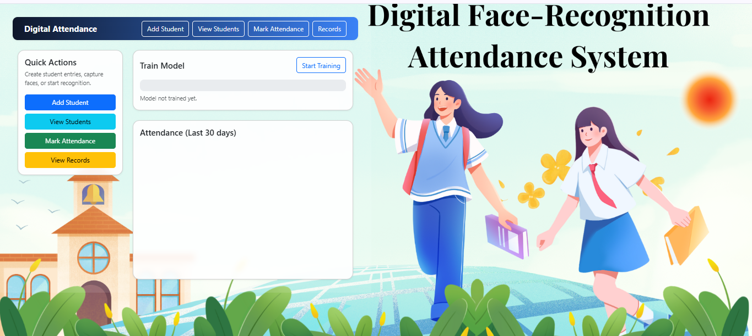

ADD STUDENT AND CAPTURE FACES
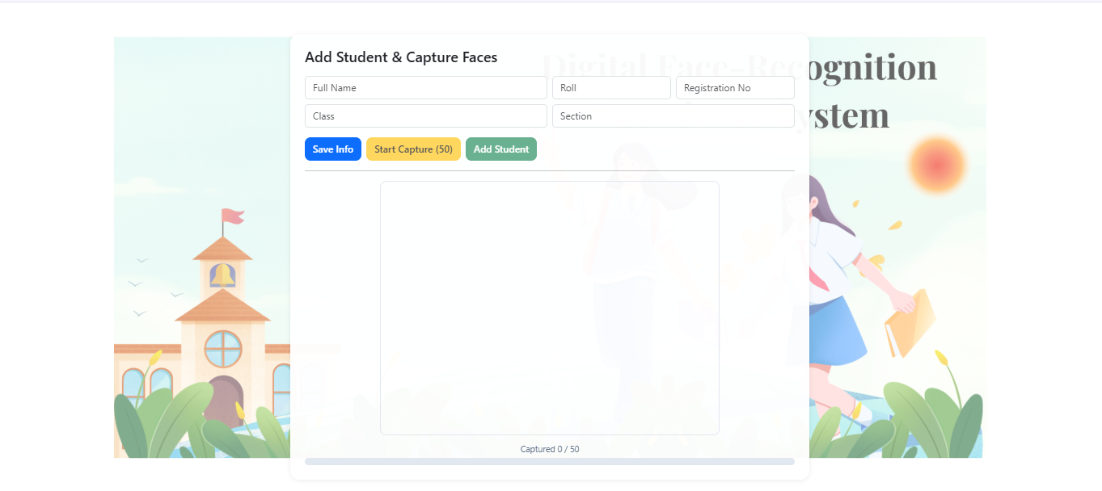

VIEW STUDENTS


MARK ATTENDENCE


VIEW RECORD
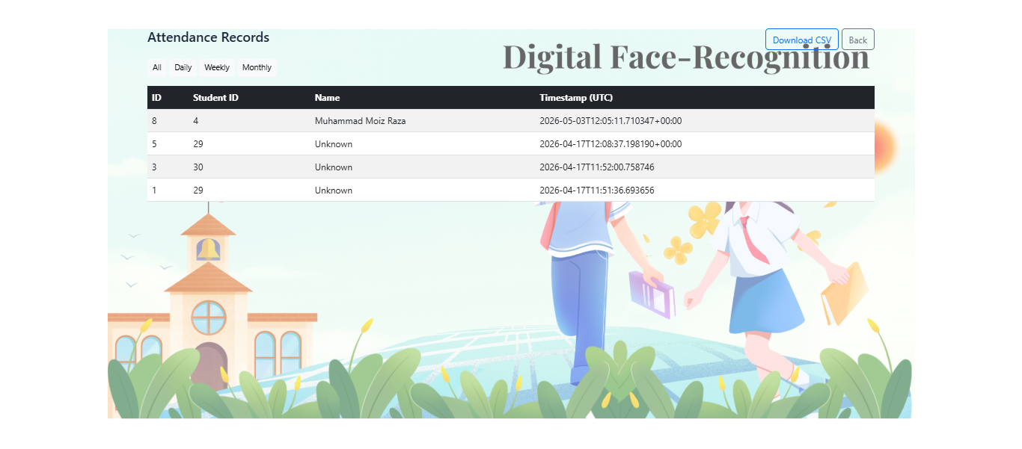

THE END

